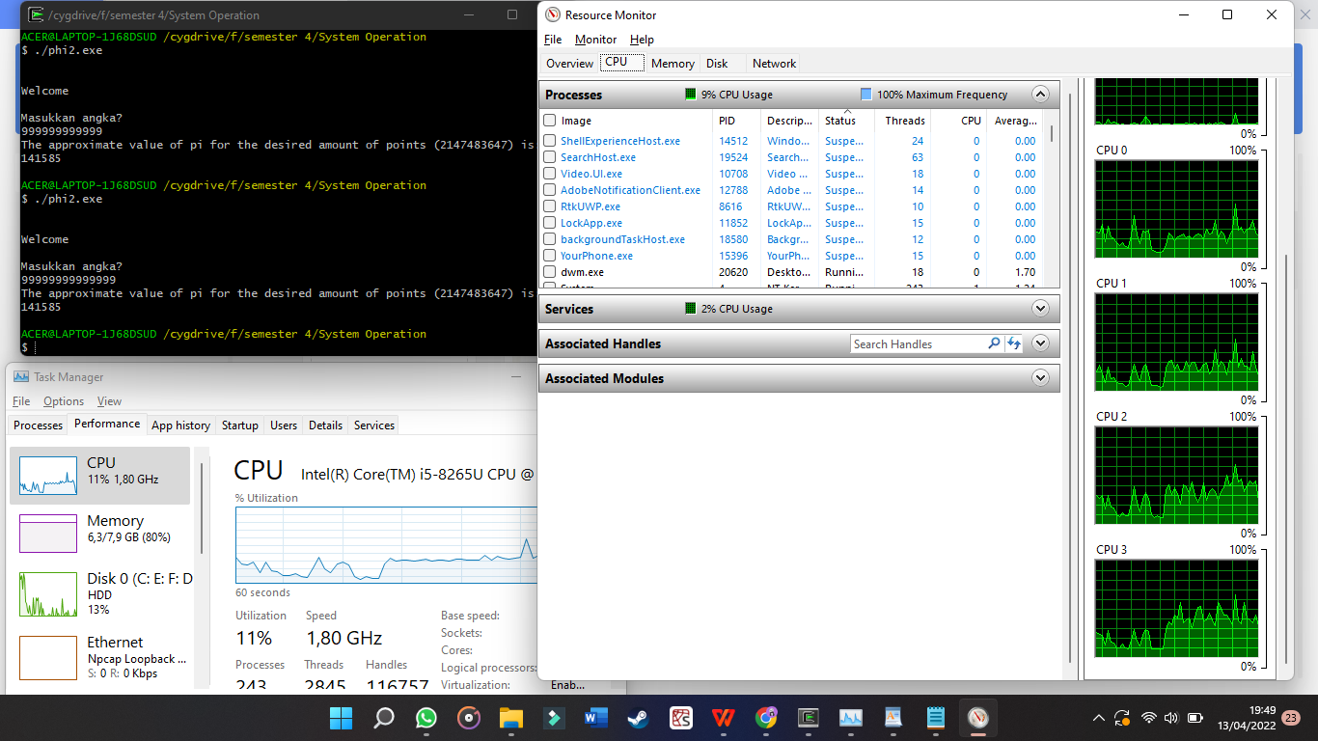

/* Program to compute Pi using Monte Carlo methods */

#include <stdio.h>

#include <string.h>

#include <pthread.h>

#include <math.h>

#include <stdlib.h>

int i = 0;

int amtWanted = 0;

int totalPts = 0;

void *count(void *X)

{

/* initialize random numbers */

for (i=0; i < amtWanted; i++)

{

double X = (double)rand() / RAND_MAX;

double Y = (double)rand() / RAND_MAX;

if (((X * X) + (Y * Y)) <= 1) //Rumus perhitungan phi

{

totalPts++;

}

}

return NULL;

}

int main()

{

printf("\n\nWelcome\n\n");

srand(time(NULL));

pthread_t thread;

//proses pemanggilan thread

do

{

printf("Masukkan Angka \n");

scanf("%d", &amtWanted);

}while (amtWanted <= 0);

pthread_create(&thread, NULL, &count, NULL);

pthread_join(thread, NULL);

double points = 4.0 * totalPts;

double pi = points / amtWanted;

printf("Phi yang di dapat (%d) is: %f \n", amtWanted, pi); //hasil dari phi

return 0;

}